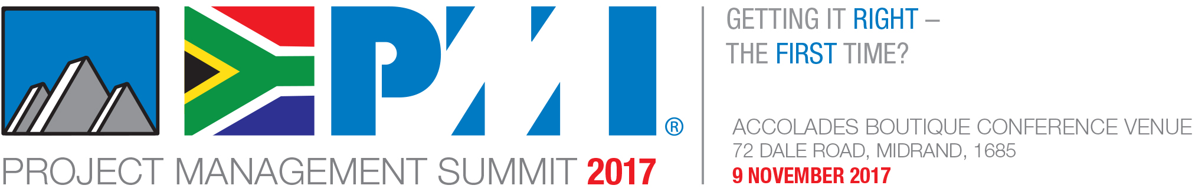

Are Your Projects Getting it Right the First Time?

PMI South Africa Chapter invites you to a knowledge sharing event like no other!

Within the increasingly challenging context of worldwide political and socio-economic instability, the need for organizational resilience and sustainable business practices has never been greater.

One of the key challenges that all organisations face is to meet goals and timelines in an environment that is ever-changing, uncertain, complex, ambiguous and volatile.
South African business leaders, much like their global counterparts, are faced with greater and rapidly shifting customer expectations, demand for enhanced value in products and services, and the endless pressure to innovate to grow market share.

For 2017, our chosen summit theme is: Getting it Right - the First Time?

This statement, presented as a question, is provocative in nature to encourage discourse and deeper thinking on the topic of getting projects right. Since projects are drivers of organisational change and means for creating value, now is the time to ask some serious questions about how what’s ‘right’ when it comes to projects, such as:

- What does it take to get a project right, the first time?
- Can, or should, we get projects right, the first time?
- How do we define 'right'?.

This year’s PM Summit 2017 promises to be as exciting and colourful as the country we live in, with a stellar line up of industry experts ranging from futurists to design thinkers, mega-project stalwarts and venture capitalist, innovators and academics. Join us for a conference such as you have never experienced before!

We'll delve into new project management approaches, with strategic emphasis on value creation for individual organisations and society. Sessions will be lively and provocative, covering stakeholder engagement, governance, leadership, benefits realisation, sustainability, design thinking, agile project management, and the importance of on-time business analytics.

Confirmed speakers include:

- Futurist and Innovator, Pieter Geldenhuys www.pietergeldenhuys.com
- Venture Capitalist, Author and Franchise Director of Discovery Holdings, Kate Moodley
- Dr Teri Okoro https://www.linkedin.com/in/teri-o-050a3120/
- Dr Alexandre Rodrigues https://www.linkedin.com/in/alexandrerodrigues/
- IT Project Management Academic, Prof Carl Marnewick https://www.linkedin.com/in/carl-marnewick-8044459/
- Mega Project Expert, Willem Louw https://www.linkedin.com/in/willem-louw-9258287/
- Design Thinker and Head of ICE at Henley Business School, Dr Puleng Makhaolibe https://www.linkedin.com/in/puleng-makhoalibe-5a77519/
- Senior Project Management Expert Dr Giel Bekker https://www.linkedin.com/in/giel-bekker-821527/
- Benefits Realisation Expert and Strategist Lea Bomvana
- https://www.linkedin.com/in/leabetswe-bomvana-0404311b/
- Consultant and Organisational Development Expert Sonja Blignaut www.linkedin.com/in/sonjablignaut
- MD of BCMG Joe Newbert - https://www.linkedin.com/in/newbert

Read all about it on http://www.pmi.org.za/pm-summit-2017/ and follow us on Twitter @PMISouthAfrica.

