Press Release | 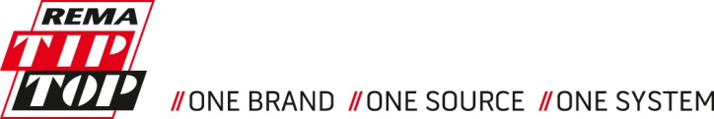

Maintenance and Service for the Rhenish lignite mining area
REMA TIP TOP provides services and products for three RWE Power open-pit mining sites in the Rhenish lignite mining area

RWE Power now exclusively relies on REMA TIP TOP for the repair and maintenance of the steel cord conveyor belts in their conveyor systems, which transport millions of tons of coal and excavation material from the open-pit mining sites in the Rhenish lignite mining area every year. A new service contract covers services that are to be provided by 120 employees over a period of ten years on-site.

Poing/Desdorf, August 7, 2017. REMA TIP TOP, a global system provider of services and products for conveyor and processing technology, has won the contract for the exclusive vulcanization of the conveyor systems for the transport of brown coal and excavation material at the open-pit mining sites of Inden, Hambach, and Garzweiler. The service contract has a term of ten years. It comprises on-site support for the open-pit mining operations and will be carried out by 120 locally employed service staff, who will be quickly available 24/7 from their conveniently located branch office in Elsdorf-Desdorf.

Reliable partnership for decades
“Since the 1950s, we have been seeing to the safe and reliable operation of the open-pit mining facilities in the Rhenish lignite mining area”, said Bernd Schimmack, Managing Director of REMA TIP TOP Desdorf. “We are constantly developing technical standards, but also safe and effective workflows together with RWE Power.” With the signing of the new contract, REMA TIP TOP has the sole long-term responsibility for the complete repair and maintenance of the vulcanization operations of the conveyor systems at three sites. “Providing an entire range of services, from the product through to the installation to sustainable service, corresponds exactly to our strategy: everything from a single source and in the highest quality”, said Thorsten Wach, CEO of the REMA TIP TOP Corporation.

The idea of providing all of the services for vulcanization in order to simplify procedures had already been introduced in 2014. At that time, several different service providers were responsible for the numerous services. REMA TIP TOP was able to win the corresponding tender for a limited period through 2017. With the now signed follow-up contract, RWE Power has shown their approval of the services rendered by REMA TIP TOP during that period. “We are very satisfied with the maintenance and support of our conveyor systems, and would like to continue to promote this development together with REMA TIP TOP”, said Dr Stephan Strunk, Section Manager of the Opencast Mining Department at RWE Power. “In this region, RWE places orders with a scale of about 800 million euros each year, often to long-standing partners. Since many years, REMA TIP TOP is among those who are providing us with services and products. We are very pleased to continue this reliable partnership.”

Focus on smooth and trouble-free operations
The smooth and trouble-free operation of the conveyor systems is one of the most important prerequisites for reliable power generation and processing of the extracted brown coal – and thus also for the supply of energy for the region. If a conveyor belt fails, the entire operation quickly comes to a halt. It is therefore crucial to recognize wear and tear as early as possible before a failure occurs, in order to be able to schedule maintenance periods in a targeted manner. If any damage suddenly occurs, it needs to be repaired as soon as possible. The service team at REMA TIP TOP focuses on the entire material transport: the conveyor belts on the conveyor lines and on large equipment (bucket wheel excavator and stacker) will be serviced, repaired, and renewed.

Visual material for this release
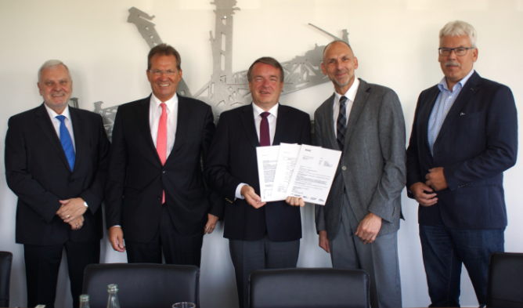  RTT_RWE.jpg | The signing of the contract (from left): Bernd Schimmack (Managing Director, REMA TIP TOP Desdorf GmbH), Hans-Joachim Herzog, (Head of Purchasing, RWE Group), Patric Scheungraber (Member of the Board of Directors, REMA TIP TOP AG), Dr Stephan Strunk (Section Manager of the Opencast Mining Department, RWE Power AG), Hans-Jürgen Dralle (Head of Mechanical Engineering at the Technical Center at the opencast mines, RWE Power AG).  Image source: REMA TIP TOP
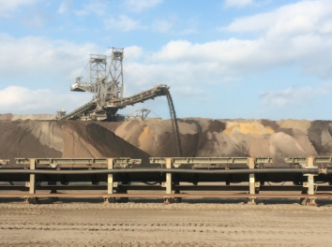  RWE Bandanlagen.jpg | Conveyors with a total length of 250 kilometres are in operation at the three open-pit mining sites in the Rhenish lignite mining area.  Image source: RWE

About REMA TIP TOP
REMA TIP TOP is a system supplier of services and products across the world for conveyor and processing technology and for tyre repair. The company has a global service network, offering a broad spectrum of rubber products, rubber linings, and coatings for industrial and automotive uses. With almost a hundred years of experience, REMA TIP TOP has collected a unique range of expertise in material development and industrial services. The company is active in the Material Processing, Surface Protection, and Automotive divisions.

At the end of the 2016 fiscal year, REMA TIP TOP had generated revenues of nearly 900 million euros. The company has over 6,300 employees across the globe, with more than 140 subsidiaries and affiliated companies – including renowned brands like Dunlop Belting Products South Africa, Cobra/Depreux, and Asplit.

Further information is available at www.rema-tiptop.de.

Press contact
REMA TIP TOP AG
Marius Schaub
marius.schaub@tiptop.de
+49 (0) 8121 / 707 10265
www.rema-tiptop.com

