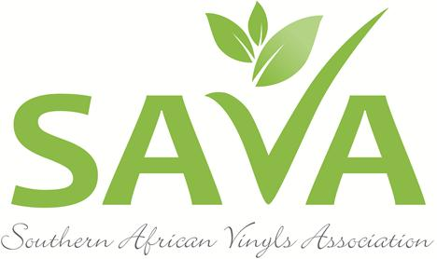
PRESS RELEASE FOR IMMEDIATE RELEASE
SA VINYLS ASSOCIATION HOSTS SUCCESSFUL VINYLS SA 2017 CONFERENCE

Johannesburg, 19 June 2017. The Southern African Vinyls Association (SAVA) hosted a successful Vinyls SA Conference at the Hilton Hotel in Sandton last week. Delegates representing the leaders of the local PVC industry, the media and other interested parties attended the presentations by international and local experts that centred around issues relating to the manufacture, use and recycling of PVC.
Above: The Vinyls SA 2017 Conference was well attended by industry representatives
“Like any other industry, the vinyls is facing various challenges that it needs to address from an environmental, health and business point of view in an ever-evolving arena. We are taking our responsibility towards sustainability seriously and are constantly reviewing our Product Stewardship Commitment to ensure that we stay abreast of developments and are proud of the progress our industry has made! The timing of this year’s event was therefore critical and we are grateful that it was so well attended,” says Delanie Bezuidenhout, CEO of SAVA.
Local and international experts share the stage
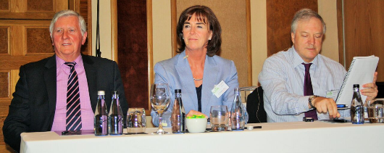
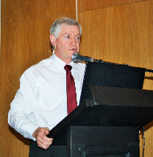
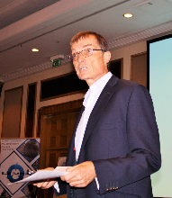

Gerhard Kuhn of the IDC

Ian Lilja, Dr Brigitte Dero andNigel Sarginson during a panel discussion

Above: Peter Willis delivers the keynote address

The Vinyl SA 2017 conference was the second international conference hosted by SAVA and built on the success of its first event that took place in 2014. Global speakers who presented papers and answered questions raised by delegates included Peter Willis, owner of “Conversations that Count”, who delivered the key-note address, Ian Lilja of the Vinyl Council of Australia (VCA), who delivered an update on the VCA Product Stewardship Programme and Dr Brigitte Dero, General Manager of the European Council for Vinyl Manufacturers and VinylsPlus, who provided an expert overview of the European Regulatory and Policy Context.
more 2/…
Local experts such as Gerhard Kuhn, Senior Economist at the IDC, Renier Snyman of DPI Plastics, Tandy Coleman of Polyflor SA and Mike Smart of Genesis Consulting provided insights into local challenges, opportunities and developments impacting the PVC industry.
vinylsa2017 conference two

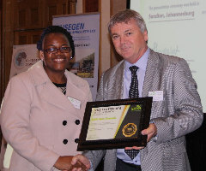
Industry Awards recognise contributions to PVC growth, development
Fulufhelo Mamathoni receives the award on behalf of SASOL from SAVA Chairman Alastair Calder.
Another highlight of the conference, was the SAVA Awards in recognition of member companies that have not only demonstrated a commitment to SAVA’s Product Stewardship Commitment (PSC), but have also proven to be 100 % compliant with all of its key undertakings.
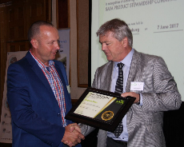
“The PSC is a series of achievable commitments that addresses the industry’s extended producer responsibility and supports the key focus areas of the association. It is therefore a great honour for us to publically thank and recognize those industry champions who are passionate about guiding the PVC industry to achieve the goals we have set in terms of sustainability,” Delanie said as she handed out certificates to Adcock Ingram Critical Care, Alpha Plast, Belgotex Floors, Chemsystems, Chembridge Additives, Cibapac, Continental Compounders, DPI Plastics, Floorworx SA, Isegen SA, Marley Pipe Systems, Mpact Limited, NCP Chlorchem, Plastichem, Polyflor SA, SASOL Polymers and SunAce South Africa.
Jaco Vermeulen of Belgotex receives his award from SAVA Chairman Alastair Calder
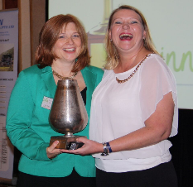
A special “Innovation in Recycling” trophy was awarded to Adcock Ingram Critical Care and Polyflor SA for their individual contributions to improving the recycling of PVC. “The main criteria for this award was that the recipients had to present a recycling initiative that has not been introduced to the South African market before, but will in the long run contribute greatly to an increase in the recycling of post-consumer PVC waste. To this end, both Adcock Ingram and Polyflor SA stood out with the innovative work they are doing in the recycling of non-hazardous PVC products in hospitals and healthcare centres, and the recycling of vinyl floor off cuts respectively,” she explained.
Tandy Coleman of Polyflor receives the Innovation in Recycling Award from Delanie Bezuidenhout, CEO of SAVA
Conclusion
“The product qualities of PVC have ensured it a place as the material of choice for many applications. As with any other material, it needs to be handled correctly, especially in certain phases of its life cycle if it is to have a role in a sustainable future for society. SAVA believes that raw material suppliers, product manufacturers, product distributors and consumers are joint stewards for the responsible and sustainable production, use and disposal of PVC products, and to this end we and our members are committed to reaching the objectives we have set for ourselves, within the agreed timeframes.
By hosting and attending conferences such as the Vinyls SA 2017, we pro-actively addresses PVC related issues and constructively engage with stakeholders and role players to create a positive environment for a vibrant and sustainable PVC industry”, Delanie concluded.
For more information about SAVA or to view presentations, visit www.savinyls.co.za
ENDS

