
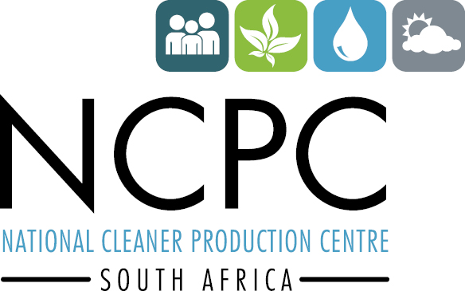



Media Release
27 February 2017

Overcoming the obstacles to an energy efficient SA

Energy efficiency lies at the core of sustained industrial and economic growth in SA, and industries and businesses must prepare more sufficiently for inevitable energy price hikes, while government should be more proactive and involved in encouraging energy efficiency. These are the findings from a panel of high-profile energy and consumer experts who participated in the Industrial Energy Efficiency Workshop on 22 February 2017.

Participants from the National Cleaner Production Centre, South Africa (NCPC-SA), Chemical and Allied Industries’ Association (CAIA), the Consumer Goods Council of South Africa and the Council for Scientific and Industrial Research (CSIR) focused on the daily challenges of rising energy costs and access to reliable alternatives.

The common consensus was that although the country has made significant strides and is even a world-leader in some aspects, overall energy efficiency is currently stifled by bottlenecks from a policy, regulatory and legislative perspective – leading to private sector apathy.

Ndivhuho Raphulu, NCPC-SA director, said energy efficiency initiatives can be used as a tool for growth in challenging economic conditions. “By investing more in research, development and innovation centres, government can accelerate energy efficiency and infrastructural development in SA with an excellent return on investment. This needs to be supported by improved policy framework, and by strategically identifying regional business opportunities with the private sector.”

Deidre Penfold, CAIA executive director, said that chemical plants are energy intense, and current energy affordability, sustainability and investment are falling short in SA. “Although there are some excellent initiatives such as the Industrial Energy Efficiency Programme, there is not enough involvement from government and that it creating a stumbling block for the industry.”

She added that the chemical industry is also an apex for upstream and downstream industry growth. “The private sector wants to grow and invest locally but cannot because a lack of cheaper energy alternatives translates into a lack of investment. Gas-to-power is a prime example of an alternative energy technology that would greatly assist the chemical industry in achieving growth.”

In addition to reducing carbon footprints, a long-term and strategic energy efficiency plan is also crucial to streamlining operational costs for business. Alexander Haw, Massmart Group sustainability manager, representing the Consumer Goods Council, said that many local companies are not aware of their own energy consumption, thereby inadvertently adding to grid constraints and adding to operational expenditure.

“It has never been easier to implement renewables as part of a business plan, as it is more readily available and competitively priced than ever before. Onsite solar farms and bio-gas plants are effective options for many businesses. The current drawback to this is that businesses can’t put energy back into the grid, and are therefore constrained in terms of planning these builds,” he said.

Crescent Mushawana, principal engineer and research group leader for energy systems at the CSIR, said government and business must work hand-in-hand to develop an energy management system and model that measures what is best for the country in terms of sustainable supply and cost trajectories. “Energy efficiency makes business sense – it is no longer a ‘nice-to-have’ option.”

In addition to the panel discussion, the Industrial Energy Efficiency Workshop also hosted presentations on best practice and case studies on workable solutions, including energy management systems, energy modelling (integration of alternatives) and energy efficiency financing. The presentations focused on providing practical solutions to industries and businesses faced with energy supply and cost challenges. To view all the presentations, please follow the link.

About NCPC-SA
NCPC-SA is a programme of The Department of Trade and Industry (the dti) hosted by the CSIR. The NCPC-SA assists industry to achieve energy and cost savings through initiatives such as the South African Industrial Energy Efficiency (IEE) Project, which has saved industry R1.7-billion in energy costs in five years.

Now in its second phase (2016-2019), the South African IEE Project is being implemented by NCPC-SA, together with international implementing agent, the United Nations Industrial Development Organization (UNIDO).

The NCPC-SA also runs the Resource Efficient and Cleaner Production (RECP) Internship Programme, where science and engineering graduates are appointed as interns to host sites that are looking to improve their RECP. The 2016 programme saved SA industry more than R7-million in resources, including 133 000 kℓ of water, after 16 manufacturing facilities nationwide each hosted an intern to conduct onsite resource efficiency assessments over a 12-month period.

Water savings accounted for 48% of overall savings, with energy savings accounting for 43%. An additional R36-million in resource savings was also identified at the plants. At a cost of just R4-million to implement, the economic and environmental benefits of the recently revamped RECP Internship Programme are immense. The 2017 RECP Internship Programme is currently underway.

For more information on the NCPC-SA and its programmes visit: www.ncpc.co.za

For more information
Julie Wells
Tell: 012 841 2424
Email: JWells@csir.co.za
www.ncpc.co.za

Constance Mokhoantle
Tel: 012 841 3926
Email: MMokhoantle@csir.co.za
www.ncpc.co.za






