August 2016

A new member is joining the eT-Hover product family
euroTECH presents a new 180° turning device at EuroBLECH

The vacuum cleaner specialist euroTECH will be presenting its new lifting device, eT-Hover-loop, and other innovations at EuroBLECH in Hanover. Between 25 and 29 October, visitors of stall C03 in hall 15 will have an opportunity to put the 180° turning device to the test. Two other lifting devices from the eT-Hover product family and an expansive range of vacuum components will also be available for testing. While the compact variety of the eT-Hover-allround proves its suitability even for limited spaces, the eT-Hover panel is positioned in the segment of horizontal panel handling.

The centrepiece of the trade show will be the new 180° turning device by euroTECH, the eT-Hover-loop. It is used for turning flat loads weighing up to 250 kilogrammes. Using a linear actuator, the device turns flat, vacuum-tight panels made of sheet metal, glass, wood or plastic with dimensions of up to 3,000 x 2,000 millimetres. Its crossbeams are adjustable and can be adapted to meet individual requirements.

The eT-Hover-panel facilitates the horizontal transport of vacuum-tight panels such as sheet metal, plastic or wooden panels. Its carrying capacity depends on the specific frame and equipment fitted. It is possible to achieve a maximum weight of up to four tonnes. All relevant processes such as vacuuming, ventilating and the operation of the crane can be controlled using a telescopic handle with an operation panel.

The modular eT-Hover-allround is a compact, versatile tool, the base unit of which can be converted individually and flexibly to fulfil a wide range of handling tasks. The compact variety has been developed in order to make the eT-Hover-allround conveniently usable in small spaces. It is fitted with a shortened, modified operating handle. This allows customers to save enormous amounts of space in restricted working areas. Despite its relatively low weight, the device holds and moves vacuum-tight loads such as sheet metal, glass panels, plastic or wooden boards with a weight of up to 500 kilogrammes.

Visitors to the euroTECH stall will also have the opportunity to try out a wide range of vacuum components.

Figures: 2240

Company profile:
euroTECH provides handling and transport solutions in the area of vacuum technology. The company develops customer-specific vacuum systems and components for automated handling tasks. The euroTECH modular construction system enables flexible adjustment of the components to the corresponding customer requirements and fast and cost-saving exchange of replacement parts.

Image attachment:

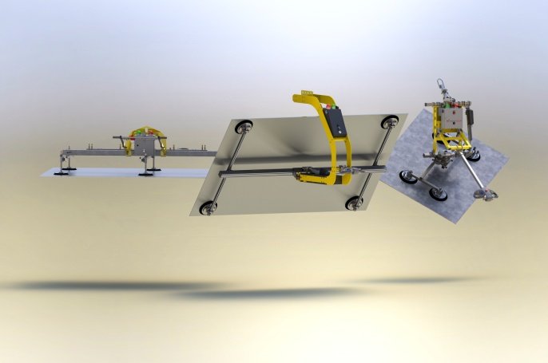
Image 1: eT-Hover-loop with eT-Hover-panel and
eT-Hover-allround

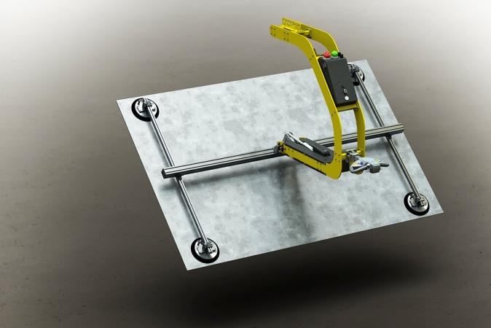
Image 2: eT-Hover-loop
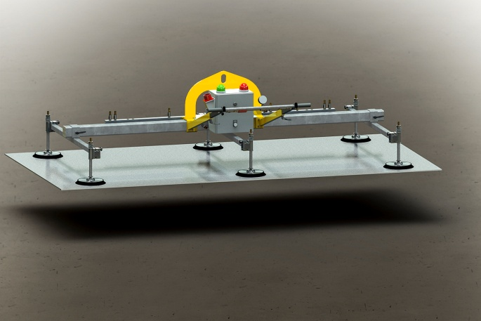
Image 3: eT-Hover-panel

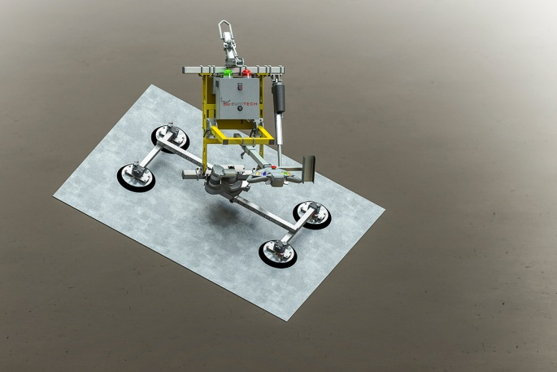
Image 4: eT-Hover-allround

Reprint free of charge, copy requested

