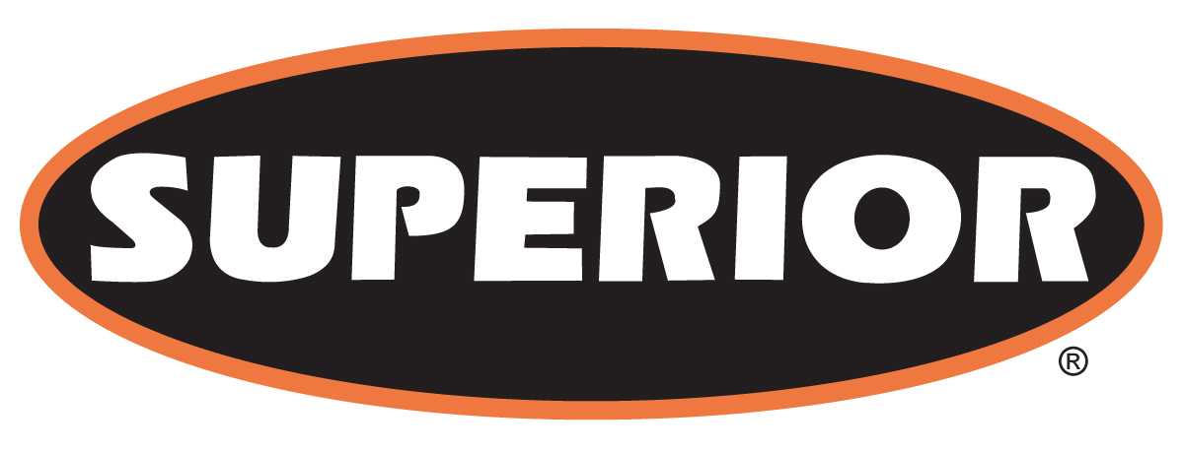

FOR IMMEDIATE RELEASE

August 22, 2016

Superior Continues Aggressive New Product Development, Debuts Freedom™ Feeder

Morris, Minn. – Superior Industries Inc., a U.S. based manufacturer and global supplier of bulk material processing and handling systems, continues development of new material processing and handling solutions from Rock Face to Load Out™ with its launch of the new Freedom™ Vibrating Grizzly Feeder (VGF). Manufactured in widths to feed up 1,400 tons per hour (TPH), Superior engineers incorporated several key, differentiating features into their designs for the Freedom Feeder.

For improved impact resistance and durability, Superior says material producers will have access to a much more robust pan section than some previous designs on the market. In addition, and exclusive to Superior, the grizzly cartridges are designed to bolt into the feeder’s frame. One set of bars are applicable for flat or 5° applications, so owners and operators can limit their stock to one style. Another key feature, says Superior engineers, are bottle jack lifting points incorporated into the spring section of the Freedom Feeder. Avoid lifting the pan with cranes or bucket loaders and simply use a bottle jack for spring replacement, which greatly increases safety during this common maintenance task.
Superior designs and manufactures its new Freedom VGF in pan widths of 36” to 60”. The same machine can be incorporated into horizontal/flat or 5° incline applications. Options include customization to the feeder’s width, grizzly sections, punch plate and finger deck.

About Superior Industries, Inc.
Superior Industries engineers and manufactures groundbreaking, bulk material processing and handling equipment and cutting-edge machinery components. From its headquarters in Morris, Minnesota, USA, the manufacturing firm supplies bulk crushing, screening, washing and conveying systems for industries including construction aggregates, mining, bulk terminals, agriculture, power and biomass. In addition to its home plant in Minnesota, the 44-year-old Superior operates from additional facilities in Arizona, Georgia, Illinois, Michigan and Nebraska, USA; Alberta and New Brunswick, Canada; and three locations in Brazil to serve South American markets.

For more information, contact:
Corey Poppe, Marketing Communications Manager
315 East State Highway 28
Morris, Minnesota 56267 U.S.A.
+1 (320) 589-2406
corey.poppe@superior-ind.com
www.superior-ind.com

