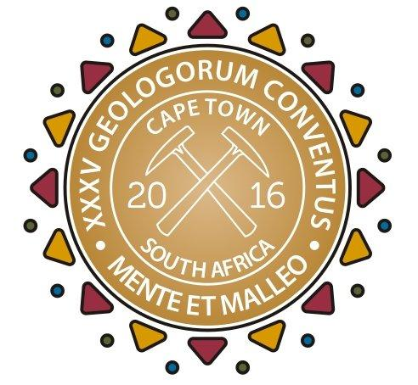
MEDIA RELEASE
Stellar speaker line-up for 35th International Geological Congress
IMMEDIATE RELEASE 10 August 2016
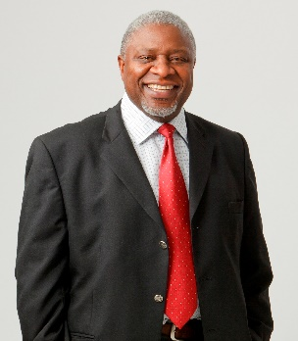
Caption: The 35th International Geological Congress is set to be an explosive event with geoscience experts from all over the world converging at the Cape Town International Convention Centre (CTICC) from 27 August to 04 September 2016. Among the diverse plenary speakers are Ruth Allington from GWP Consultants in the United Kingdom (left image), Anusuya Chinsamy-Turan from the University of Cape Town (middle image) and Sipho Nkosi, former CEO of Exxaro Resources Limited (right image).
The International Geological Congress (IGC) brings together subject experts from all of the geosciences. The broad range of topics covered include everything from mining and volcanology to medical geoscience, geoethics and palaeobiology – all captured in three core topics: geoscience for society, geoscience in the economy and fundamental geoscience. With over 4 000 presentations, the IGC is jam-packed with information and invaluable networking opportunities. Some of the most important sessions to look forward to are the ten plenary presentations that will be taking place during the IGC, with the best qualified professionals to present them.
‘Geoscience for society’ covers aspects where the geoscience meets the public. Plenary speaker Ruth Allington from GWP Consultants will present her views on how the geosciences can better service society by bridging the gap between academic science, applied geoscience and geological research. Similarly, Michel Jebrak from the University of Quebec will address how geologists in mining are key to helping the industry become more socially and environmentally responsible.
John Anderson from the Nelson Mandela Metropolitan University will discuss the Africa Alive Corridors Project, which aims to explore the history of mankind in Africa and use knowledge of this heritage to uplift all the people on the continent. Geosciences also meet society inasmuch as it mitigates the effect of natural disasters on human lives – Mustapha Meghraoui will discuss advances in the African seismic studies that will increase the accuracy of earthquake hazard assessment.
The second core topic, ‘geoscience in the economy’, mainly pertains to how geology, through mining, contributes to national financial well-being. Sipho Nkosi, former Chief Executive Officer of Exxaro Resources Limited, will be the first plenary speaker to explore this theme. He will discuss how Africa’s mining industry can develop to gain the greatest possible economic benefit. Thomas Graedel from Yale University will explore how the mining industry might better optimise use of metals along various parts of the metal life cycle, while Joe Cartwright from the University of Oxford will delve into the challenges faced by the shale gas industry.
Lastly, ‘fundamental geoscience’ forms an important part of this congress that celebrates the full breadth and depth of the geosciences. Plenary speaker Bob Scholes from the University of Witwatersrand will explain how Earth system processes and human development influenced each other since the beginning of history, while Anusuya Chinsamy-Turan from the University of Cape Town will be presenting on how bone growth and development in extinct species have been determined by historical fossil studies. Finally, Chris Hawkesworth from the University of Bristol will elaborate on how the continental crust comes into being.
“The line-up for this year’s IGC comprises a truly exceptional set of speakers and presenters,” says Laurence Robb, Scientific Programme Chair of the 35th IGC. “The IGC being hosted in South Africa is a once-in-a-lifetime event. If you are interested in anything related to the geosciences, do not miss it,” concludes Robb.
Registrations are open. Visit http://www.35igc.org/Verso/60/Registration to sign up.
For more information about the IGC visit http://www.35igc.org/. Join the 35th IGC Facebook page at https://www.facebook.com/35thigc/.
###
Released by Reputation Matters
Media contact:
Nalene de Klerk
Mobile Number: 081 411 6089
nalene@reputationmatters.co.za

