Darling Brew introduces Africa’s First Carbon Neutral Beer

Darling Brew in South Africa has launched the first carbon neutral beer in Africa, Blood Serpent.
With the reaffirmation at Cop 21 that the global temperature rise needs to be capped at 2 degrees from pre-industrialised levels, calls have been made for decarbonisation and company buy-in for carbon neutrality. The entry of Blood Serpent into the market could mean progress and momentum for the South African beer industry to be a part of a necessary global change.
Owners Kevin and Philippa Wood are proud to deliver a first in Africa and to introduce a more sustainable craft beer option into the market. A carbon neutral beer process and carbon neutral certification has been achieved through innovative brewing, packaging and offsetting processes.
Darling Brew have pursued to link their beers with sustainability and conservation since opening in 2010. “Since the beginning, each beer has been inspired by an endangered creature which is honoured and supported through conservation programmes,” says Kevin, “for Blood Serpent, we chose the Secretary Bird.”
Classified as a vulnerable species according to the IUCN Red List, the Secretary Bird (Sagittarius Serpentarius) has a distinct profile, quite unlike that of any other bird. “This made it the perfect choice of animal,” says Philippa, as Blood Serpent is unlike that of any other beer in the market.”
For Blood Serpent, Darling Brew teamed up with sustainability consultants Ecolution Consulting in order to ensure that the beer offsetting process was done correctly and that the offsets were validated by recognised verification bodies for carbon offsetting.
“Ecolution assisted Darling Brew in conducting a green house gas audit to quantify the carbon equivalent footprint of the production of Blood Serpent,” says André Harms, Director of Ecolution, “we are proud to be a part of achieving this feat.”
In order to achieve a carbon neutral beer, Darling Brew has offset the scope 1 and 2 emissions of the Blood Serpent process, as well as the scope 3 emissions associated with packaging. The carbon emissions created by the fuel, water and energy consumption during brewing, as well as the glass, labels and packaging during production, are thus offset with each new batch of Blood Serpent.

The offsetting process is done through the Kariba REDD+ project in Zimbabwe with impactChoice as an offsetting partner. It was chosen based on the fact that the project has emissions reductions that are real, measurable and permanent. REDD+ is an acronym for Reducing Emissions from Deforestation and Forest Degradation. Their aim is to empower local communities whilst preserving forests and protecting wild life. The carbon offsets are validated by the Verified Carbon Standard, the Gold Standard and the Plan Vivo.

For every 16 000 bottles of Blood Serpent produced (of which 6000 have been bottled and distributed) the equivalent emissions produced by an average car driving 38 894 km is offset (4033.64 Kg of Co2-e). In terms of carbon sequestered, the offset is equivalent to 261 tree seedlings having grown for 10 years.

The home of Blood Serpent - The Taste Room - has been kitted out with tables, chairs and light fittings made from recycled items such as beer baths and wooden palettes.

The brewery has also taken to reduce water consumption through sunken water tanks, water-saving nozzles and by reusing as much water as possible.

Ingredients sourced for the Taste Room are local with a focus on Fairtrade and organic produce where possible, whilst the spent grain from the brewing process is not simply discarded, but used as food for some of Darling’s resident cattle.

The team at Darling Brew are proud of this milestone on their sustainability journey, but it will not stop here. “We are assessing ways in which we can make our brewery more efficient, “says Kevin, “and we will continue to find ways to innovate our operations and our beers.”
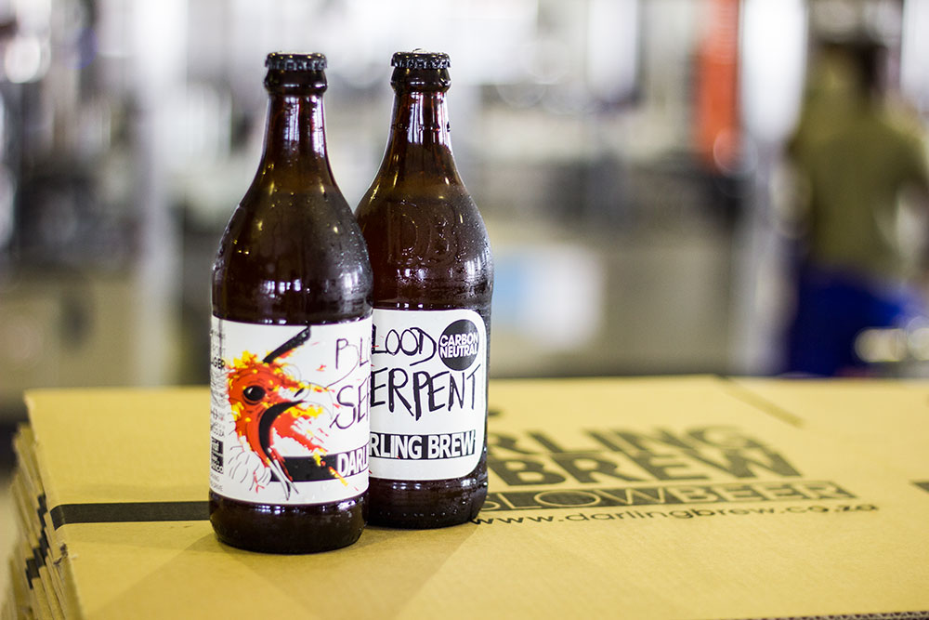

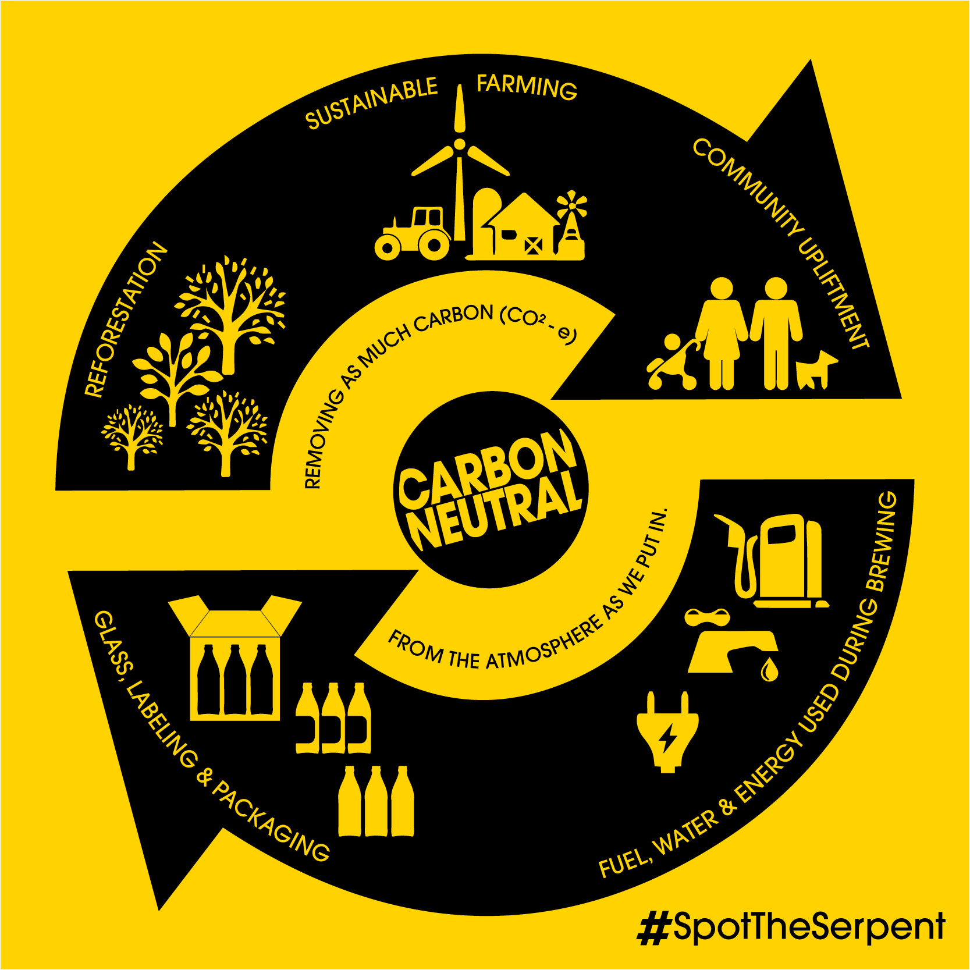

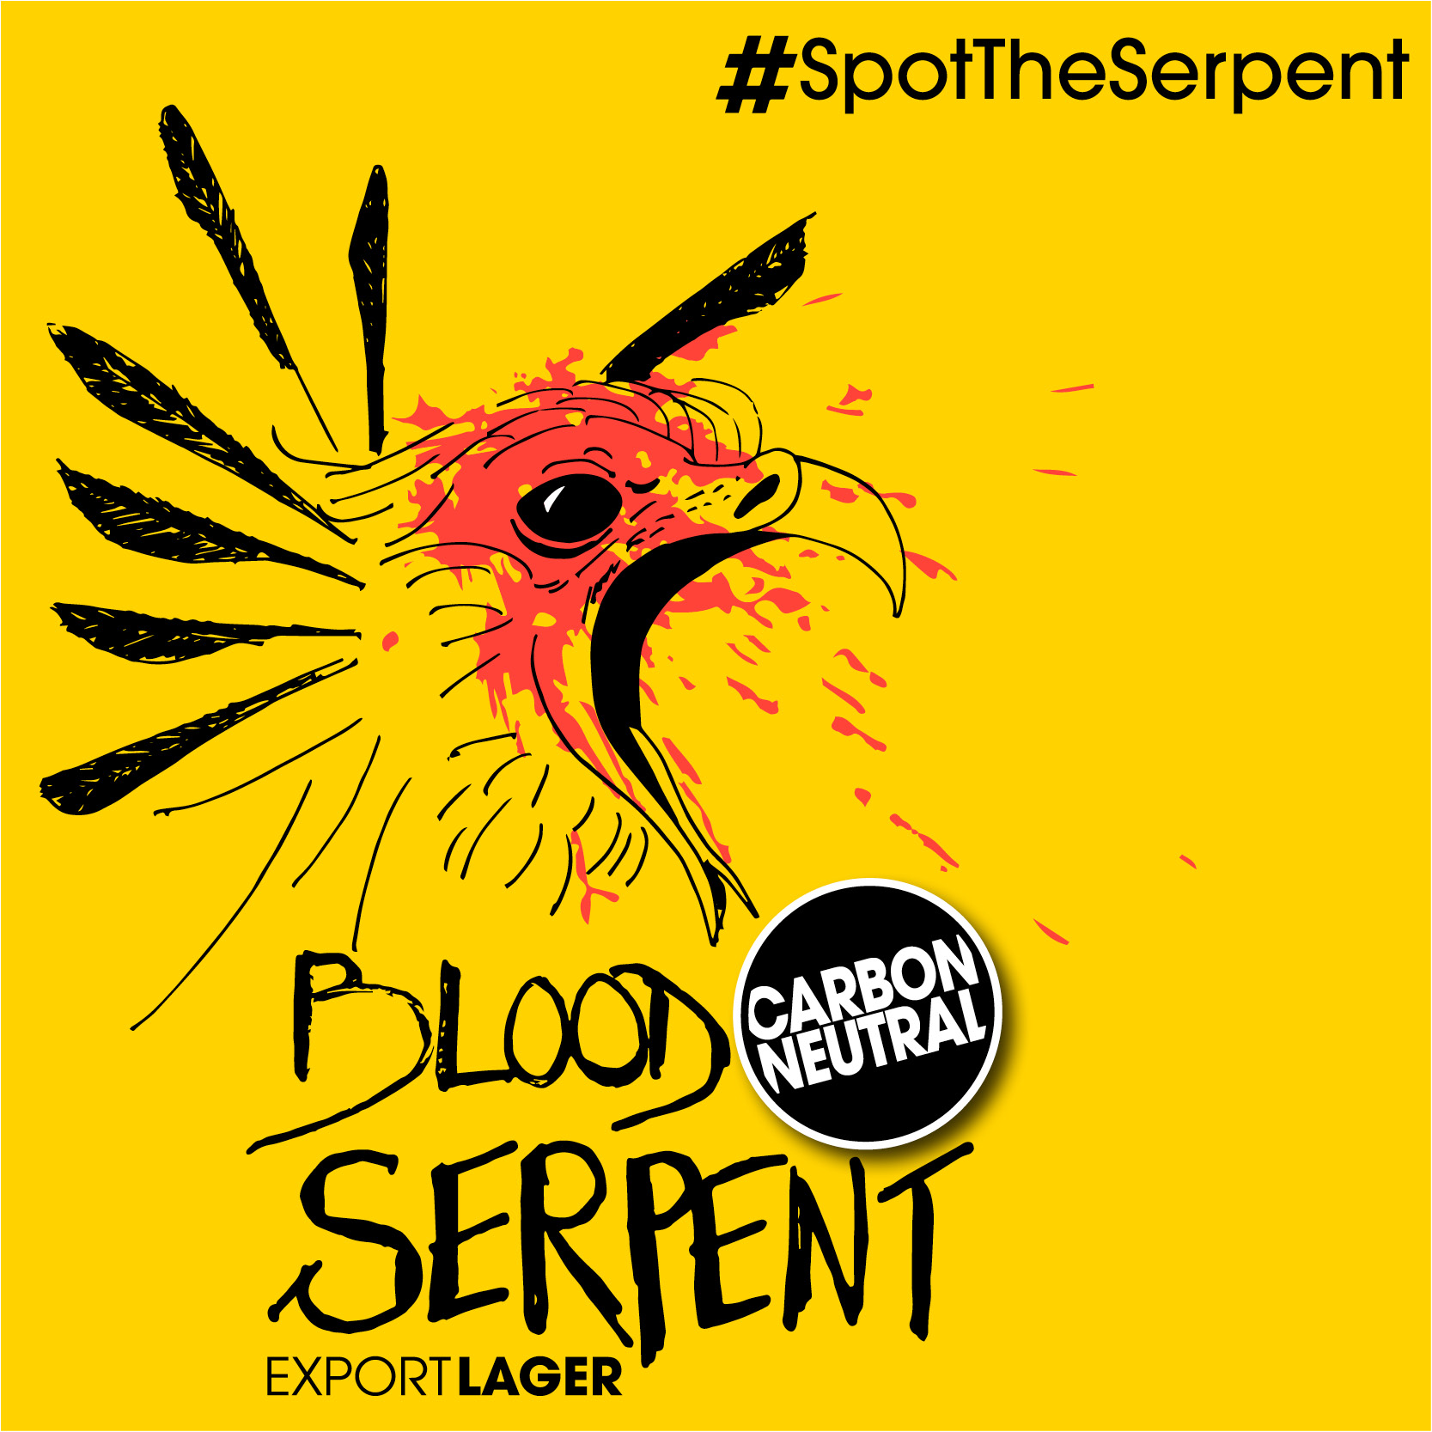

Additional Information and note to Editors:
Darling Brew
Darling Brew is a microbrewery located in the small town of Darling in the Western Cape. The brewery produces a wide range of popular craft beers. Each beer in their range has unique characteristics and a backstory dedicated to the endangered creature it honours and supports through the various conservation programmes that they donate to.
It all started in 2007 when owners Kevin and Philippa Wood journeyed into Africa to see as much wildlife as they could and explore the many different beers of each country. They brewery opened in 2010. Most recently they have constructed a new micro-brewery and Taste Room which offers an interactive beer tasting experience in the tasting room and bar which overlooks the working microbrewery, a restaurant that serves delicious beer paired meals made from fresh, organic, seasonal and locally sourced ingredients, and beautiful gardens.
Darling Brew’s new premises are situated at 48 Caledon Street in Darling.
Blood Serpent Outlets:

www.darlingbrew.co.za
Twitter: @DarlingBrew
Facebook: Darling Brew
Kariba Redd+
The Kariba REDD+ Project supported by Darling Brew is located on the shores of Lake Kariba in Northern Zimbabwe spanning an area of 785 000 hectares. It connects several game reserves and national parks including Mana Pools National Park and Chizarira. Over the past few years, Northern Zimbabwe has lost 3% of its forest cover, whilst wildlife populations have become threatened and effected. The project aims to combat these negative effects and uplift the local communities in the process with financial support from project supporters.

The project has emissions reductions that are real, measurable and permanent. The Carbon Offsets are validated by recognised verification bodies such as the Verified Carbon Standard, the Gold Standard and the Plan Vivo.

These are some of the ways in which the Kariba Redd+ Project is making real change happen:

• Providing year-round food security
• Protecting local biodiversity and conserving natural resources
• Creating employment opportunities
• Facilitating new sources of sustainable income generation
• Promoting gender parity and the empowerment of women
• Strengthening social infrastructure through education and healthcare
• Upholding indigenous cultural identity whilst providing a platform for training and knowledge transfer
More Information on Kariba Redd+
Ecolution Consulting
Ecolution Consulting is a professional sustainability consulting firm that provides expert insights, solutions and consulting services for businesses in any industry and buildings of any nature. Their services assist clients who are striving to be an environmentally responsible business.
“As a combined force, alongside our clients, we will act as a catalyst for a change towards bettering our world.”
The Ecolution Vision: We live, work and play sustainability!
www.ecolution.co.za
Twitter: @EcolutionC
Facebook : Ecolution Consulting

For more information:

Contact

Sarah Farrell

+27 83 409 5557

Marketing@darlingbrew.co.za

